**启德英国UK尊享留学规划方案**

**亲爱的陈同学：**

非常感谢您选择启德英国项目中心，愿我们的专业服务为您的留英之旅领路引航，愿我们的贴心关怀助您开启未来的全新旅程！我是您的启德英国教育顾问余静文，全程为您提供专属留英服务。

作为高等教育的发源地，英国在教育质量和院校资源等方面一直走在世界前列；作为英语发源地，英国吸引了一批又一批来自世界各地的莘莘学子；作为一个多元化国家，英国以平和包容的心态接纳各民族文化；作为一个既古典又现代的国家，在英国既能欣赏经典艺术又能感受国际化大都市的发达科技；作为一个与欧洲大陆隔海相望的国家，英国的旅游资源丰富、交通发达，您可以享受一场说走就走的旅行！

在准备赴英留学的过程中，也许您会遇到困难和挫折，但请不要担心，启德英国的专业团队将全程陪伴，为您提供前期咨询、方案定制、院校申请、语言培训、职业规划、签证办理、接机住宿安排、行前指导、升学转学等优质高效的服务！

为帮助您了解启德英国团队的服务，我们制作了此份赴英留学专案，请妥善保管，方便日后我们为您提供更加细致的留学服务！

**选择启德办理英国留学的八大理由**

* 首批获得教育部认证的留学服务机构（教外综资认字【2002】230号）
* 提供“一站式”服务，从咨询到离境，让您享受全方位的留学服务体验
* 集团全程把控分公司的服务环节，保证每一位客户享受优质高效的服务
* 众多海归顾问以亲身经历分享留学经验，助您掌握第一手实用留学资讯
* 常年高密度举办英国名校面试招生活动、英国专项教育展和留学分享会
* 院校资源丰富，是全国最大的、英国院校官方授权的招生代理机构之一
* 积累30余年专业留学服务经验，已帮助数十万中国学子实现留学梦想
* 留英签证申请成功率接近100%，曾经成功为众多有拒签史的学生平反

**世界百强名校眼中的启德英国项目中心**

“启德是格拉斯哥大学在中国的重要合作伙伴，我们共同为中国学生提供相应的 服务，帮助大家实现留学的梦想。”

——格拉斯哥大学东亚区负责人

“The University of York is pleased to have been working successfully with EIC since 2006 to help students realise their UK study ambitions. EIC have a proven track record of offering professional and student-focused guidance to help students choose the best study destination for them. Education counsellors are well trained and provide helpful and accurate information to guide students to through the application and visa process. The University of York values its relationship with EIC and looks forward to successful cooperation in the future.”

——Gwion Sims International Officer (East Asia), University of York

“EIC are one of The University of Manchester’s carefully selected partners in China. They offer a comprehensive service from initial counselling through to getting your CAS. I have always found their counsellors to be friendly with a good knowledge of The University’s programmes and application processes and you can be assured that you will receive a first-class service.”

—— Charlie Pybus International Officer, The University of Manchester

 “Loughborough University has been working with EIC for the past 15 months and I am impressed by the professionalism and effectiveness of their UK team. EIC has been very supportive in our office visit requests and other recruitment related activities such as departure briefings. EIC also runs a number of exhibitions across China each year and the Guangzhou exhibitions are always busy with good quality enquirers.”

——Yinghui Gilbert Regional Manager, Loughborough University

**启德英国项目中心赴英学习专案设计**

|  |  |
| --- | --- |
| **申请人基本信息** | |
| 姓名：陈家杰 | 性别：男 |
| 目前就读学校：澳门理工大学 | 最高学历：大四 |
| 就读/辅修专业：计算机 | 平均成绩：3.12/80% |
| 常用邮箱： | 手机/固话： |
| **客户留学意向** | |
| 拟入读时间：202209 |  |
| 申请专业方向： 计算机 | 申请学习层次：研究生 |

**根据客户提供的资料和申请要求，经本机构评估后，赴英学习专案设计如下：**

**University of Nottingham诺丁汉大学**

* **Data Science MSc**

雅思：6.5 with at least 6.0 in each element

**课程设置：**

* Core Modules

Research Project

* Optional Modules

Machine Learning

Knowledge, Representation and Reasoning

Advanced Algorithms and Data Structures

Computer Vision

Simulation and Optimisation for Decision Support

Data Modelling and Analysis

Professional Ethics in Computing

Computability

Parallel Computing

Programming

Data Modelling and Analysis

Computer Vision

Machine Learning

Simulation and Optimisation for Decision Support

（课程信息请点击下链接认真阅读）

<https://www.nottingham.ac.uk/pgstudy/course/taught/Data-Science-MSc>

* **Computer Science or Computer Science (Artificial Intelligence) MSc**

雅思：6.5 with at least 6.0 in each element

**课程设置：**

* Core Modules

Research Methods

Students without a background in computer science must take the following:

Programming

Systems and Networks

Databases, Interfaces and Software Design Principles

Students wishing to obtain MSc Computer Science (Artificial Intelligence) must select 40 credits from the list below:

Machine Learning

Autonomous Robotic Systems

Linear and Discrete Optimisation

Designing Intelligent Agents

Games

Data Modelling and Analysis

Fuzzy Logic and Fuzzy Systems

Simulation and Optimisation for Decision Support

* Optional Modules

Computability

Designing Intelligent Agents

Games

Computer Graphics

Software Engineering Management

Data Modelling and Analysis

Fuzzy Logic and Fuzzy Systems

Mixed Reality Technologies

Fundamentals of Information Visualisation

Information Visualisation Project

Programs, Proofs and Types

Knowledge Representation and Reasoning

Design Ethnography

Programming

Machine Learning

Advanced Algorithms and Data Structures

Advanced Computer Networks

Autonomous Robotic Systems

Systems and Networks

Databases, Interfaces and Software Design Principles

Project in Advanced Algorithms and Data Structures

Linear and Discrete Optimisation

Real-world Functional Programming

Real World Functional Programming Project MSc

Simulation and Optimisation for Decision Support

（课程信息请点击下链接认真阅读）

<https://www.nottingham.ac.uk/pgstudy/course/taught/Computer-Science-or-Computer-Science-(Artificial-Intelligence)-MSc>

**University of Southampton南安普顿大学**

* **MSc Computer Science**

雅思：6.5 overall, with a minimum of 6.0 in all components

**课程设置：**

* Core Modules

[MSc Project](http://www.southampton.ac.uk/courses/modules/comp6200.page)

[Topics in Computer Science](http://www.southampton.ac.uk/courses/modules/comp6233.page)

[Project Preparation](http://www.southampton.ac.uk/courses/modules/elec6211.page)

* Optional Modules

[Advanced Databases](http://www.southampton.ac.uk/courses/modules/comp3211.page)

[E-Business Strategy](http://www.southampton.ac.uk/courses/modules/comp6201.page)

[Evolution of Complexity](http://www.southampton.ac.uk/courses/modules/comp6202.page)

[Intelligent Agents](http://www.southampton.ac.uk/courses/modules/comp6203.page)

[Software Project Management and Development](http://www.southampton.ac.uk/courses/modules/comp6204.page)

[Web Development](http://www.southampton.ac.uk/courses/modules/comp6205.page)

[Advanced Intelligent Agents](http://www.southampton.ac.uk/courses/modules/comp6207.page)

[Advanced Machine Learning](http://www.southampton.ac.uk/courses/modules/comp6208.page)

[Automated Code Generation](http://www.southampton.ac.uk/courses/modules/comp6209.page)

[Biometrics](http://www.southampton.ac.uk/courses/modules/comp6211.page)

[Computational Finance](http://www.southampton.ac.uk/courses/modules/comp6212.page)

[Open Data Innovation](http://www.southampton.ac.uk/courses/modules/comp6214.page)

[Semantic Web Technologies](http://www.southampton.ac.uk/courses/modules/comp6215.page)

[Simulation Modelling for Computer Science](http://www.southampton.ac.uk/courses/modules/comp6216.page)

[The Science of Online Social Networks](http://www.southampton.ac.uk/courses/modules/comp6217.page)

[Web Architecture](http://www.southampton.ac.uk/courses/modules/comp6218.page)

[Designing Usable and Accessible Technologies](http://www.southampton.ac.uk/courses/modules/comp6219.page)

[Computer Vision (MSc)](http://www.southampton.ac.uk/courses/modules/comp6223.page)

[Foundations of Cyber Security](http://www.southampton.ac.uk/courses/modules/comp6224.page)

[Software Modelling Tools and Techniques for Critical Systems](http://www.southampton.ac.uk/courses/modules/comp6226.page)

[Network and Web Based Security](http://www.southampton.ac.uk/courses/modules/comp6230.page)

[Foundations of Artificial Intelligence](http://www.southampton.ac.uk/courses/modules/comp6231.page)

[Data Visualisation](http://www.southampton.ac.uk/courses/modules/comp6234.page)

[Foundations of Data Science](http://www.southampton.ac.uk/courses/modules/comp6235.page)

[Software Security](http://www.southampton.ac.uk/courses/modules/comp6236.page)

[Data Mining](http://www.southampton.ac.uk/courses/modules/comp6237.page)

[Mobile Applications Development](http://www.southampton.ac.uk/courses/modules/comp6239.page)

[Foundations of Machine Learning (MSc)](http://www.southampton.ac.uk/courses/modules/comp6245.page)

[Machine Learning Technologies (MSc)](http://www.southampton.ac.uk/courses/modules/comp6246.page)

[Reinforcement and Online Learning](http://www.southampton.ac.uk/courses/modules/comp6247.page)

[Deep Learning](http://www.southampton.ac.uk/courses/modules/comp6248.page)

[Biologically Inspired Robotics](http://www.southampton.ac.uk/courses/modules/elec6212.page)

[Image Processing](http://www.southampton.ac.uk/courses/modules/elec6213.page)

[Cryptography](http://www.southampton.ac.uk/courses/modules/elec6242.page)

（课程信息请点击下链接认真阅读）

<https://www.ecs.soton.ac.uk/programmes/msc_computer_science#modules>

**Cardiff University**

**Advanced Computer Science (MSc)**

雅思：verall score of 6.5 with 5.5 in all subskills, or an accepted equivalent.

**课程设置：**

* Core Modules

[Programming Paradigms](https://www.cardiff.ac.uk/study/postgraduate/taught/courses/course/advanced-computer-science-msc)

[Dissertation](https://www.cardiff.ac.uk/study/postgraduate/taught/courses/course/advanced-computer-science-msc)

* Optional Modules

The University is committed to providing a wide range of module options where possible, but please be aware that whilst every effort is made to offer choice this may be limited in certain circumstances. This is due to the fact that some modules have limited numbers of places available, which are allocated on a first-come, first-served basis, while others have minimum student numbers required before they will run, to ensure that an appropriate quality of education can be delivered; some modules require students to have already taken particular subjects, and others are core or required on the programme you are taking. Modules may also be limited due to timetable clashes, and although the University works to minimise disruption to choice, we advise you to seek advice from the relevant School on the module choices available.

（课程信息请点击下链接认真阅读）

<https://www.cardiff.ac.uk/study/postgraduate/taught/courses/course/advanced-computer-science-msc#optional-modules-1-1>

**Newcatle University**

**1、Computer Science MSc**

雅思：6.5 overall (with a minimum of 5.5 in all sub-skills)

**课程设置：**

[Introduction to Software Development](https://www.ncl.ac.uk/postgraduate/degrees/module/?code=CSC8011)

[Software Development Techniques and Tools](https://www.ncl.ac.uk/postgraduate/degrees/module/?code=CSC8012)

[Professional skills and Portfolio](https://www.ncl.ac.uk/postgraduate/degrees/module/?code=CSC8013)

[Software Development Advanced Techniques](https://www.ncl.ac.uk/postgraduate/degrees/module/?code=CSC8014)

[Cybersecurity](https://www.ncl.ac.uk/postgraduate/degrees/module/?code=CSC8015)

[Advanced Programming](https://www.ncl.ac.uk/postgraduate/degrees/module/?code=CSC8016)

[Database Systems](https://www.ncl.ac.uk/postgraduate/degrees/module/?code=CSC8017)

[Web Technologies](https://www.ncl.ac.uk/postgraduate/degrees/module/?code=CSC8018)

[Software Engineering and Team Project](https://www.ncl.ac.uk/postgraduate/degrees/module/?code=CSC8019)

[Computer Networks](https://www.ncl.ac.uk/postgraduate/degrees/module/?code=CSC8021)

[Human Computer Interaction](https://www.ncl.ac.uk/postgraduate/degrees/module/?code=CSC8022)

[Project and Dissertation for MSc Computer Science](https://www.ncl.ac.uk/postgraduate/degrees/module/?code=CSC8099)

（课程信息请点击下链接认真阅读）

<https://www.ncl.ac.uk/postgraduate/degrees/5055f/#entry-requirements>

**2、Data Science MSc**

雅思：6.5 overall (with a minimum of 5.5 in all sub-skills).

**课程设置：**

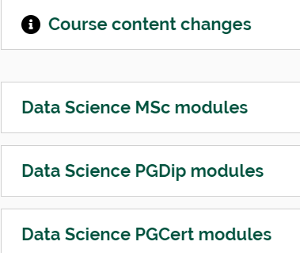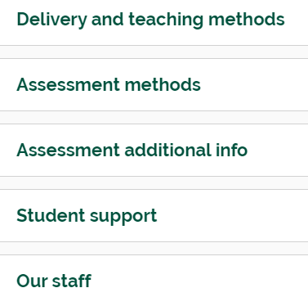

（课程信息请点击下链接认真阅读）

<https://www.ncl.ac.uk/postgraduate/degrees/5395f/#entry-requirements>

**Queen Mary，University of London**

**1、Computer Science MSc**

雅思：6.5 overall including 6.0 in Writing, and 5.5 in Reading, Listening and Speaking.

**课程设置：**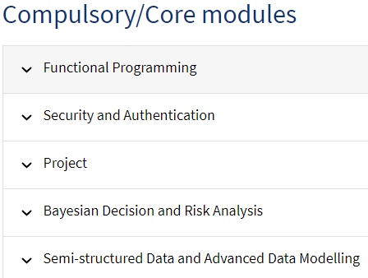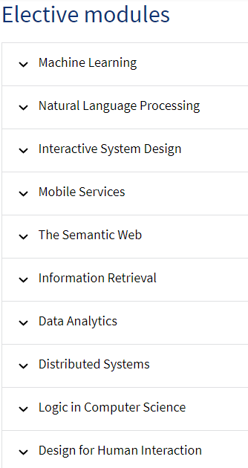

（课程信息请点击下链接认真阅读）

<https://www.qmul.ac.uk/postgraduate/taught/coursefinder/courses/computer-science-msc/>

**2、Big Data Science MSc**

雅思：6.5 overall including 6.0 in Writing, and 5.5 in Reading, Listening and Speaking.

**课程设置：**

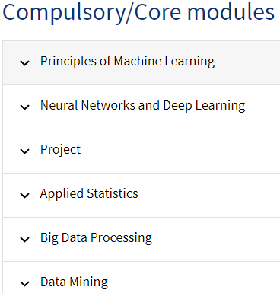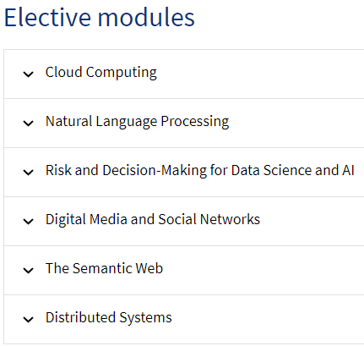

（课程信息请点击下链接认真阅读）

<https://www.qmul.ac.uk/postgraduate/taught/coursefinder/courses/big-data-science-msc/>